English Nursery and Primary School

Moscow



Child Protection and Safeguarding Policy

September 2021

Review date June 2022

*Schools have a duty of care to protect children and prevent them from harm, and act with a sense of urgency if a child is at risk of harm.*

*Expectations are based on the following principles:*

*All children have equal rights to be protected from harm and abuse.*

*Everybody has a responsibility to support the protection of children.*

*All schools have a duty of care to children enrolled in the school and those who are affected by the operations of the school.*

*We believe this policy should be a working document that is fit for purpose, represents the school ethos, enables consistency and quality across the school and is related to the following:*

United Nations Convention on the Rights of the Child (UNCRC).

*Council of International Schools Accreditation Standards 2016*

*The standards and expectations were developed by the International Task Force on Child Protection (ITFCP)*

*International best practice from the UK*

**Policy**

A values statement about the rights of the child has been developed and formally adopted by the school that is aligned with the responsibilities set out in the United Nations Convention on the Rights of the Child (UNCRC).

The school has developed and adopted an appropriate definition of child abuse including physical, emotional or sexual abuse, sexual exploitation, neglect and commercial or ideological exploitation and inappropriate behaviour of children towards other children.

School safeguarding and child protection policies and procedures are subject to an annual scheduled review and revision.

The school has recruitment policies and executes rigorous recruitment procedures that ensure all employees and volunteers are of sound moral character and are suitable people to work with children and young adults.

People

The school has clearly defined leadership responsibilities for child safety and duty of care.

Formal procedures are followed for conducting criminal record and background checks on prospective and existing faculty, staff, volunteers, contractors, and others who may come into contact with students.

Formal procedures are followed to obtain and verify references for prospective and existing faculty and staff.

The school has developed and enacts a code of conduct and written guidelines for appropriate and inappropriate behaviours of adults towards children and children towards other children. All faculty, staff, volunteers and contractors acknowledge that they have read the code of conduct and agree to abide by it.

The school has a scheduled program of annual professional training for volunteers, contractors, faculty and staff on student safeguarding, child abuse prevention, recognition, intervention and reporting.

Procedures

The school shall have in place formal learning programs at all age levels related to child protection which cover areas such as bullying personal safety, physical abuse, manipulation, grooming, online safety, healthy sexual behaviour, neglect and negligent behaviour, self-harm, staying safe away from home, commercial exploitation and disclosing abuse. These programs to be delivered by members of faculty or external providers who are trained in these areas.

The school has developed structured procedures for reporting suspected or disclosed maltreatment or abuse, including historical disclosure, and adopts a formal policy identifying actions to be taken, including informing appropriate authorities.

The school develops meaningful and effective relationships with external organisations and bodies that are able to provide appropriate support and advice on matters related to child protection.

Child protection measures are integrated with all procedures and systems (strategic planning, budgeting, recruitment, program management, performance management, procurement, partner agreements, risk management and management systems etc.).

Due regard is given to building and facility design, layout, designation and use to ensure best practice in child safety and protection, within the context of the host country.

Accountability

The school is cognizant of and complies with the legal, ethical and cultural expectations and requirements regarding child abuse within the country in which it operates.

All reports of suspected or disclosed abuse and any actions taken by the school are securely archived, regardless of the conclusions reached.

**Preamble**

We are committed to safeguarding and promoting the welfare of all children as the safety and protection of children is of paramount importance to everyone in this school. At all times we will ensure what is best in the interests of all children.

Safeguarding and promoting the welfare of children is best defined as:

'protecting children from maltreatment; preventing impairment of children's health or development; ensuring that children grow up in circumstances consistent with the provision of safe and effective care; and taking action to enable all children to have the best outcomes'.

We believe that all children have the right to be safe in our society. Therefore, we recognise that we have a duty to ensure arrangements are in place for safeguarding and promoting the welfare of children by creating a positive school atmosphere through our teaching and learning, pastoral support and care for both pupils and school personnel, training for school personnel and with working with parents.

We understand that 'safeguarding is what we do for all children, whilst child protection refers to the procedures we use for children at risk of significant harm or who have been harmed.'

We work hard to ensure that everyone keeps careful watch throughout the school and in everything we do for possible dangers or difficulties. We want all children to feel safe at all times. We want to hear their views of how we can improve all aspects of safeguarding and from the evidence gained we put into place all necessary improvements.

We want all our children to achieve their full potential by:

* being as physically and mentally healthy as possible;
* experiencing good quality education opportunities;
* living in a safe environment;
* learning and working in a safe environment;
* experiencing emotional well being;
* feeling loved and valued;
* receiving support from a network of reliable and affectionate relationships;
* learning to look after themselves;
* coping with everyday living;
* having a sense of identity and a positive image of themselves;
* developing their confidence and their interpersonal skills

We recognise that the safety and protection of pupils is the responsibility of all school personnel and volunteers as they are in a unique position to notice injuries, marks or bruises when children are undertaking certain activities which might indicate a child has been abused. We believe that we must report and investigate all injuries for the safety and protection of the children in our care.

We acknowledge that children can be harmed physically, emotionally, sexually or by neglect. It is our duty to report any concerns that we have of child abuse as the health, safety and protection of all children is paramount. We are aware that if abuse is suspected by another child then child protection procedures will be applied to both children.

We understand abuse to be the maltreatment of a child. While:

* physical abuse is a 'form of abuse which may involve hitting, shaking, throwing, poisoning, burning or scalding, drowning, suffocating or otherwise causing physical harm to a child';
* emotional abuse is the 'persistent emotional maltreatment of a child such as to cause severe and adverse effects on the child’s emotional development.';
* sexual abuse 'involves forcing or enticing a child or young person to take part in sexual activities, not necessarily involving a high level of violence, whether or not the child is aware of what is happening';
* neglect is the 'persistent failure to meet a child’s basic physical and/or psychological needs, likely to result in the serious impairment of the child’s health or development.'.

We are aware that sexual exploitation 'can take many forms from the seemingly ‘consensual’ relationship where sex is exchanged for attention/affection, accommodation or gifts, to serious organised crime and child trafficking. What marks out exploitation is an imbalance of power within the relationship. The perpetrator always holds some kind of power over the victim, increasing the dependence of the victim as the exploitative relationship develops.' We will report any concerns we may have regarding a pupil being possibly sexually exploited.

We have a duty to safeguard children, young people and families from violent extremism. We are aware that there are extremist groups within any country who wish to radicalise vulnerable children and to involve them in terrorism or in activity in support of terrorism.

School personnel must be aware of the increased risk of online radicalisation, and alert to changes in pupil's behaviour. Any concerns will be reported to the Designated Safeguarding Lead.

We provide a safe environment where we promote pupils' welfare and resilience.

We are committed in establishing and maintaining an ethos where children and parents feel secure in being able to talk confidently to school personnel about any concerns or fears they may have knowing that they will be taken seriously.

We will ensure that the curriculum deals with safeguarding through activities and opportunities in PSHE/Psychology that will equip the children with the necessary skills and awareness to stay safe from abuse. We want children to understand risk, to become more resilient and know where to go for help and support not only in school but also in the local community.

We have a duty to create and maintain a culture of safe recruitment and to establish and maintain correct procedures that will 'help deter, reject or identify people who might abuse children.' Procedures, such as 'criminal record checks (Police/ DBS checks), barred list checks and prohibition checks together with references and interview information' to be used in order to determine the suitability of a prospective employee.

We are committed in establishing and maintaining correct procedures and checks for safer recruitment for all new staff, supply staff, contractors, volunteers and governors and the establishment of sound working relationships with parents and support agencies.

We will ensure that all adults in the school community attends regular awareness training on a wide range of safeguarding topics and that Designated Safeguarding Leads undertake two-yearly training in their role.

We have a duty to ensure that under no circumstances will we disclose to a parent any information held on a child if this would put the child at risk of significant harm.

We believe that 'everyone who comes into contact with children and their families has a role to play in safeguarding children'. Therefore, we believe it is essential that this policy clearly identifies and outlines the roles and responsibilities of all those involved in the procedures and arrangements that is connected with this policy.

We believe it is essential that this policy clearly identifies and outlines the roles and responsibilities of all those involved in the procedures and arrangements that are connected with this policy. All SLT must be fully aware of their safeguarding responsibilities.

**Responsibility for the Policy and Procedure**

**Role of the Director and Central Administration**

The Director and Central Admin has:

* appointed members of the senior leadership team to act as the Designated Safeguarding Lead and Deputy Designated Safeguarding Lead;
* in place job descriptions for both the Designated Safeguarding Lead and the Deputy Designated Safeguarding Lead;
* has delegated powers and responsibilities to the Headteacher to ensure everyone connected with the school is aware of and complies with this policy;
* responsibility to ensure this policy is effective and updated annually;
* responsibility to ensure other linked policies are up to date and reviewed when required;
* to use the experiences and expertise of school personnel when writing and reviewing safeguarding and child protection policies;
* responsibility to ensure that there are excellent lines of communication and the sharing of information with local agencies such as social services, the police and health care services;
* in place safe recruitment procedures, including appropriate use of reference checks on new staff and volunteers;
* responsibility to ensure Disclosure and Barring Service checks are undertaken for everyone working with children in the school;
* in place procedures to deal with allegations of abuse against members of staff and volunteers;
* responsibility to ensure that the Headteacher, school personnel and volunteers undertake regular safeguarding training;
* responsibility to ensure pupils are taught about safeguarding as part of a broad and balanced curriculum;
* responsibility to annually review all safeguarding policies and procedures;
* responsibility for ensuring funding is in place to support this policy;
* responsibility for ensuring all policies are made available to parents;

**The SLT will:**

* ensure the implementation of this policy, all procedures and other related policies;
* ensure everyone in the school community is fully aware of this policy;
* publish this policy:
* ensure all school personnel and volunteers understand the safeguarding risks to children and how to report any concerns they may have;
* work closely with the Designated Safeguarding Lead for child protection;
* nominate a deputy Designated Safeguarding Lead;
* ensure both Designated Safeguarding Leads undertake two-yearly training in their role;
* organise, in conjunction with both Designated Safeguarding Leads, regular awareness training on a wide range of safeguarding topics for all adults in the school community;
* keep an updated training attendance record with the administrator and ensure that those who were absent from any training attend another follow up training session;
* provide evidence for Inspectors that training has been effective and has been implemented;
* provide adequate resources for the Designated Safeguarding Lead to undertake his/her role;
* ensure a safer recruitment process is in place;
* ensure Disclosure and Barring Service checks are undertaken for everyone working with children in the school;
* ensure all visitors are suitably checked and monitored;
* ensure that all school personnel and volunteers are able to highlight improvements to the safeguarding policies and procedures;
* ensure that all new staff undertake training in child protection procedures;
* create and provide a learning environment that is safe, secure, warm and welcoming for children combined with sound security systems and procedures;
* have in place IT systems that will effectively filter the internet without over-blocking and systems to monitor online usage;
* ensure school personnel and pupils do not take photographic images without consent or management permission;
* ensure risk assessments are in place regarding physical intervention, personal care, intimate care, pupils changing for sporting activities, school personnel working 1:1 with a pupil, overnight stays and staying with hosting families on exchange visits;
* establish an environment where children feel safe to talk and a culture where school personnel listen to children;
* not promise confidentiality to any child but always act in the interests of a child;
* have in place effective anti-bullying strategies;
* ensure school personnel are constantly encouraging pupils to assess risks to themselves;
* ensure school personnel have the skills, knowledge and understanding to keep looked after children safe;
* ensure school personnel are aware of the additional safeguarding challenges to children with special educational needs and disabilities;
* ensure that there is a smooth transition of responsibilities and information when a new Designated Safeguarding Lead takes over the role;
* undertake training in safeguarding and child protection;
* provide leadership and vision in respect of equality;
* make effective use of relevant research and information to improve this policy;
* provide guidance, support and training to all staff;
* ensure all school personnel are familiar with:
* this policy
* School Personnel Code of Conduct policy
* Dealing with Allegations of Abuse against Teachers and other Staff
* monitor the effectiveness of this policy;
* report annually to the governing body on the effectiveness of the policy.

**The Designated Safeguarding Lead will:**

* ensure the implementation of this policy;
* ensure everyone connected with the school is aware of this policy;
* be trained in child protection policy procedures;
* renew training every two years in order to;
* understand the specific needs of children in need
* have in place a secure and accurate record system of all concerns and referrals
* receive appropriate annual updates;
* take the lead in dealing with child protection issues and in deciding what steps should be taken;
* take into 'account the child's wishes and feelings when determining what action to take and what services to provide';
* raise awareness of the need to protect pupils who might be vulnerable to radicalisation and involvement in terrorism;
* ensure all confidential child protection information is stored securely in central place;
* ensure that no information will be disclosed to a parent if this would put a child at risk of significant harm;
* familiarise school personnel with the policy and procedures;
* investigate and deal with all cases of suspected or actual problems associated with child protection;
* ensure parents are aware that referrals about suspected abuse or neglect may be made;
* make child protection referrals to children's social care or if need be to the police and then to wait for a decision about the type of response required;
* take appropriate action if a child's situation does not improve after a referral has been made by pressing for re-consideration;
* record all child protection referrals;
* co-ordinate action within the school;
* liaise with SLT and Psychology team
* record the transfer of all child protection files of any pupil leaving to join another school
* provide support for any child at risk;
* not promise confidentiality to any child but always act in the interests of a child;
* act as a source of advice within the school;
* help create a culture within the school of listening to children;
* keep up to date will all new guidance on safeguarding children;
* keep all school personnel up to date with any changes to procedures;
* organise appropriate training for school personnel and governors;
* ensure all incidents are recorded, reported and kept confidential;
* keep all paperwork up to date;
* report back to the appropriate school personnel when necessary;
* ensure that there is a smooth transition of responsibilities and information when a new Designated Safeguarding Lead takes over the role;
* annually review the policy.

**School Personnel and Volunteers**

Staff must:

* recognise that child protection is their main responsibility and will 'always act in the best interests of the child';
* remember to make a written record of all verbal conversations;
* make a referral to children's social care or to the police if a child is in immediate danger or at risk of harm and then record the verbal conversation in writing;
* then inform the designated safeguarding lead that a referral has been made;
* maintain an attitude of 'it could happen here' where safeguarding is concerned';
* 'identify concerns early, provide help for children, and prevent concerns from escalating';
* speak with the designated safeguarding lead if they are unsure and then record the verbal conversation in writing;
* provide a safe environment in which children can learn;
* ensure pupils:
* feel safe and protected;
* know how to assess risk to themselves;
* know how to keep themselves safe;
* know how to raise a complaint or concern;
* know and recognise a trusted adult that they can go to and raise their concerns;
* feel supported and protected when they raise a concern;
* are kept informed of any actions that have been taken when they have raised a complaint;
* feel safe from discrimination and bullying;
* treat children’s welfare with utmost importance;
* be aware of the background of the children in their care;
* be made aware of this policy and all other safeguarding policies and procedures during induction
* be aware of the online tool 'Reporting child abuse to your local council';
* attend regular awareness training on a wide range of safeguarding topics;
* be aware of the name of the Designated Safeguarding Lead;
* understand the role of the Designated Safeguarding Lead;
* be trained in identifying signs of harm and abuse;
* be aware of child sexual exploitation, radicalisation and extremism;
* be aware of the effects of abuse and neglect on children;
* undertake training on responding to a child;
* be alert at all times to the signs of abuse namely physical, emotional, sexual or neglect;
* know how to report any suspected case of harm or abuse;
* be aware they face disciplinary procedures if they fail to comply with the mandatory duty;
* inform the Designated Safeguarding Lead of any child who they suspect is being privately fostered;
* report any concerns that they have about pupils who may be vulnerable to radicalisation;
* establish a school and classroom environment where children feel safe to talk and where school personnel listen to children;
* provide opportunities through the curriculum to address relevant issues and topics in order to promote their safety and well-being;
* encourage pupils to assess risks to themselves;
* report any concerns to the Designated Safeguarding Lead or the deputy Designated Safeguarding Lead;
* know what to do if a child makes a disclosure;
* not promise confidentiality to any child but always act in the interests of a child;
* receive support and counselling if they feel distressed from being involved with a case or incident;
* be cautious when using social networking sites and must:
* set their profile as private;
* not allow access to pupils or parents/carers;
* avoid publishing or allowing to be published any material/comments/images that could damage their professional reputation or bring the school into disrepute.
* not outside school hours make contact with pupils or parents/carers via telephone, text message, email or on social networking sites;
* not give their personal details such as mobile and home telephone numbers, home or email address;
* report to the Headteacher any concerns they may have about another member of staff;
* report to the Head Psychologist any concerns they may have about the Headteacher;
* report to the SLT any concerns they may have about poor or unsafe safeguarding practices
* be kept up to date with changes in procedures;
* ensure that they conduct themselves correctly at all times and do not put themselves at risk;
* be aware of the Safer Recruitment processes and checks;
* implement the school’s equalities policy and schemes;
* report and deal with all incidents of discrimination;
* attend appropriate training sessions on equality;
* report any concerns they have on any aspect of the school community.

**Pupils**

Pupils must:

* feel safe and protected;
* know how to assess risk to themselves;
* know how to keep themselves safe;
* know how to raise a complaint or concern;
* know and recognise a trusted adult that they can go to and raise their concerns;
* feel supported and protected when they raise a concern;
* feel safe from discrimination and bullying;

**Role of and Partnerships with Parents**

Parents are:

* asked to work hard with the school to establish excellent home-school relationships;
* aware that we have a responsibility for the welfare of all our pupils;
* aware that we have a duty to involve Social Services or any other agency if we have any concerns about a child;
* aware that they will be kept up to date with all our actions.

**Process:**

The school will ensure that:

* We have a DSL for child protection who has received appropriate training, updated every 2 years and support for this role.
* We have a senior member of staff who will act in the designated person’s absence, who has also received appropriate training.
* We operate safe recruitment procedures and make sure every adult within our school who has access to children has been checked as to their suitability. At least one member of Senior staff has had appropriate training in safer recruitment procedures.
* Every member of staff (including temporary and supply staff and volunteers) knows the name of the designated senior person responsible for child protection and their role.
* Every member of staff reads, understands, signs and abides by the Staff Code of Conduct.
* All staff and volunteers understand their responsibilities in being alert to the signs of abuse and responsibility for referring any concerns to the designated senior person responsible for child protection. Staff will receive appropriate training updated every year to develop their understanding of the signs and indicators of abuse, how to respond to a pupil who discloses abuse and the procedure to be followed in sharing a concern of possible abuse or a disclosure of abuse.
* All new staff are made aware of the school’s policy and procedures as part of their induction into the school.
* We develop effective links with relevant agencies and co-operate as required with their enquiries regarding child protection matters, ensuring that any member of staff found not suitable to work with children will be notified to the the relevant authorities within Russia and their home country.
* We follow procedures where an allegation is made against a member of staff or volunteer.
* We monitor children known or thought to be at risk of harm. Keep written records of concerns about children, even where there is no need to refer the matter immediately, ensuring that all such records are kept confidentially and securely and are separate from pupil records.

**Symptoms**

Some of the signs and behaviours which may indicate that a child is being abused:

* repeated minor injuries
* children who are dirty, smelly, poorly clothed or who appear underfed
* children who have lingering illnesses which are not attended to, deterioration in school work, or significant changes in behaviour, aggressive behaviour, severe tantrums
* an air of 'detachment' or 'don't care' attitude
* overly compliant behaviour
* a 'watchful attitude'
* sexually explicit behaviour (e.g. playing games and showing awareness which is inappropriate for the child's age), aggressive and inappropriate sex play
* a child who is reluctant to go home, or is kept away from school for no apparent reason
* does not trust adults, particularly those who are close
* 'tummy pains' with no medical reason
* eating problems, including over-eating, loss of appetite
* disturbed sleep, nightmares, bed wetting
* running away from home, suicide attempts
* self inflicted wounds
* reverting to younger behaviour
* depression, withdrawal
* relationships between child and adults which are secretive and exclude others.

These signs are not evidence themselves; but may be a warning, particularly if a child exhibits several of them or a pattern emerges. It is important to remember that there may be other explanations for a child showing such signs. Abuse is not easy to diagnose, even for experts.

The Headteacher and the Director take specific responsibility for child protection matters in the school. Any member of staff who is told of any incident or suspicion of physical, emotional or sexual child abuse occurring in the school, or to a pupil of the school, at home or outside the school, must report the information, immediately.

Child abuse to be reported includes abuse of a pupil by a staff member or other adult, abuse at home which a pupil reports to staff, abuse by a stranger outside school, and abuse of one pupil by another pupil.

School staff should NOT investigate reports of physical or sexual abuse themselves. Alleged victims, perpetrators, those reporting abuse and others involved should not be interviewed by school staff beyond the point at which it is clear that there is an allegation of abuse.

Staff members, and other adults, at the school, should NEVER give absolute guarantees of confidentiality to pupils or adults wishing to tell them about something serious. They should guarantee that they will only pass on information to the minimum number of people who must be told in order to ensure that proper action is taken.

Staff should make it clear that they will never tell anyone who does not have a clear need to know.

If an allegation of physical or sexual abuse is made a staff member should:

* Keep questioning to a minimum, strictly avoiding 'leading' the pupil.
* React professionally and calmly without becoming emotionally involved.
* Stop asking questions as soon as the pupil has disclosed they believe something abusive has happened to them or to someone else.
* Where appropriate and possible (according to the age and understanding of the child) the staff member will tell the informing pupil that the staff member will now make sure the appropriate people are brought in to follow up the problems and make it clear why unconditional confidentiality cannot be offered.
* The staff member may also (if appropriate as above) ask the informing pupil what steps they would like taken to protect them now they have made an allegation, and assure them that the school will try to follow their wishes. Encourage him/her to speak directly to the designated person.
* Make a written record of what has been said.
* Refer the matter immediately, with all the relevant details, to the Headteacher or designated person, as above.
* In very serious cases the Police should be informed from the outset following discussion with the Headteacher or designated person.

You should only contact the Headteacher or designated person.

Concern about the behaviour of another member of staff towards a pupil

If a teacher or member of staff has concerns about the behaviour of another member of staff towards a pupil, he or she should report it at once to the Headteacher. Any concern will be thoroughly investigated. If there is evidence of criminal activity, the Police will always be informed. Wherever possible, and subject to the rights of the pupil, the member of staff will be informed of the outcome of the investigation. No-one who reports a genuine concern in good faith needs to fear retribution.

This policy covers the procedures that will be set into operation in the event that an allegation of abuse is made against any member of staff who is employed at the school. The allegations could concern the abuse of one, or more pupils. They could also concern the abuse of children who are not connected with the school. The procedures cover the initial actions, those taken during the investigatory phase and the actions taken in the aftermath. They cover situations when allegations are found to have no substance, situations when they are shown to be well-founded, and situations when an employee’s behaviour, although possibly unwise, or even incompetent or negligent, fell short of being criminal in either action or intent.

Allegations that a member of staff has abused a pupil or pupils either inside the school premises or during a school trip or visit could be made by:

* Parents
* The abused pupil
* Other members of staff
* Other pupils
* Former pupils
* The Police or Social Services
* A third party

An allegation of such seriousness would normally be made directly to the Headteacher or other designated person but if another member of staff is told first, he/she will ensure that the Headteacher or other designated person is informed immediately.

If we are faced with an anonymous allegation of child abuse which names both a member of staff and a child, we will handle it in exactly the same way as if we knew the identity of the person making the allegation. Where the allegation names the member of staff; but not the pupil, we will normally interview the member of staff, and ask for his or her version of events. It could be appropriate to establish a mentoring or review programme for that individual, or to provide him or her with further training. A record would be kept on the individual’s personal file.

We will respond promptly and sensitively to the legitimate concerns of the victim and his family. We undertake to:

* Take any allegation of abuse, involving a member of staff, very seriously,
* Establish the facts before jumping to any conclusion,

Although a formal investigation is a matter for specialists, where the facts suggest that there may be reasonable grounds for suspecting actual abuse, or grooming of a child, or other criminal behaviour, we will always:

• Invite the police to conduct the investigation,

• Consider suspending the member of staff (or volunteer) concerned.

Our priority is to safeguard the children in our care. We will give all the support that we can to a pupil who has been abused. The Headteacher, together with the SLT where appropriate, will consider how best to support and monitor the pupil concerned through any process of investigation, liaising closely with parents, guardians, or other agencies involved to identify the support strategies that will be appropriate.

Suspension of a member of staff is a neutral act and does not imply that any judgement has been reached about his or her conduct. Even so, it is a serious step, and we will take legal advice beforehand, and will normally only suspend a member of staff where:

* There is a serious risk of harm (or further harm) to the child,
* The allegations are so serious as to constitute grounds for dismissal, if proven,
* The police are investigating allegations of criminal misconduct.

We recognise fully that we have a duty of care towards all of our staff, and we will always:

* Keep an open mind until a conclusion has been reached.
* Interview a member of staff before suspending him or her.
* Keep him or her informed of progress of the investigation.

We will always consider whether an alternative to suspension might be appropriate.

Possibilities include:

• Sending the member of staff on leave,

• Giving him or her non-contact duties,

• For a teacher, ensuring that a second adult is always present in the classroom.

The resignation of a member of staff or volunteer mid-way through an investigation would not lead to the investigation being abandoned. Our policy is always to complete every investigation into allegations of child abuse.

We will record all allegations of abuse, and our subsequent actions, including any disciplinary actions, on an individual’s file. A copy will be given to the individual and he or she will be told that the record will be retained until he or she reaches statutory retirement age, or for ten years, if that is longer.

A child who has been the centre of unfounded or unsubstantiated allegations of child abuse needs professional help in dealing with the aftermath.

However much support the child may need in such circumstances; we need to be sensitive to the possibility that the aftermath of an unfounded allegation of abuse may result in the irretrievable breakdown of the relationship with the teacher. In such circumstances, we may conclude that it is in the child’s best interests to move to another school. We would do our best to help him/her to achieve as smooth a transition as possible, working closely with the parents or guardians.

Allegations found to be malicious should be removed from personnel records and should not be referred to in employer references.

Confidentiality

A member of staff who raises a concern is entitled to have his/her name protected from being disclosed by the Headteacher to the alleged perpetrator, without his/her prior approval.

However, it has to be recognised that his/her evidence may be required by the Police to be used in any criminal proceedings.

Reporting Concerns

If a pupil makes a disclosure then the member of the school personnel must:

* listen to the pupil;
* remain calm;
* offer reassurance;
* not ask the pupil to remove or adjust clothing if bruises are observed;
* not ask leading questions;
* let the pupil speak freely;
* accept what has been told them without challenge;
* not offer opinion or criticise or lay blame;
* reassure the pupil at the end of the disclosure telling them that they have done the right thing;
* not promise confidentiality but inform them that other people need to be told;
* record accurately and factually what the child has said in note form;
* record observed injuries or bruises on a map of the body;

If a member of the school personnel suspects that a child may be a victim of abuse then they must:

* record accurately and factually what they have seen in note form;
* submit a completed critical incident sheet to the designated person;

The Designated Safeguarding Lead will then:

* further investigate and keep records of this investigation;
* decide whether to take this referral further or to monitor the situation;
* inform the person making the initial referral of his/her decision;
* prepare in readiness for a case conference/core group meeting the following information on the child:
* attendance and punctuality data
* academic achievement
* child’s behaviour and attitude
* relationships and social skills
* appearance and presentation
* any known incidents in or outside school
* school contact with parents/carers

If a parent makes a disclosure to school then the Designated Safeguarding Lead:

* should meet with the parent taking down all details;
* will assure the parent that the school will take the matter seriously;
* will get back to the parent when a decision has been taken and how to proceed.

Recording Information

The school record and concern sheet (with a body map) must be completed in detail and signed

School personnel and volunteer helpers are asked to record any concern or incident with specific details that include:

|  |  |
| --- | --- |
| * Date * Time * Place * Nature of the concern | * All facts * Observed injuries and bruises * Note the actual words of the child * Sign the notes and hand to the DT |

Support

* We will ensure that support mechanisms are in place for any child that is at risk in order to build their self-esteem and confidence;
* School personnel and volunteer helpers who feel distressed from being involved with a case or incident will receive support and counselling.

Confidentiality and Security of Information

* It is imperative that confidentiality is observed at all times as the protection of the child is paramount.
* School personnel have a professional responsibility to share information with other professionals who are investigating a case.
* A child, when confiding information to a member of staff, must be made aware that for the child’s own sake this information cannot be kept secret.
* The child must be reassured that the information will only be shared with the designated teacher who will decide what will happen next.
* All child protection records are regarded as confidential and will be kept in a secure place.

As part of the recruitment process

The following information will be recorded for all school personnel, trainee teachers and volunteers:

* an identity check
* a DBS check/certificate
* a check of professional qualifications
* Russian Police check
* Police checks from other countries worked in

**Training**

Training will take place for school personnel annually that will review the policy and procedures

* Child protection issues
* Recognising signs of abuse
* Handling disclosures

including

* What to do if a child is being abused
* Understanding and knowing how to overcome the additional safeguarding vulnerabilities of learners with SEN and disabilities

**Raising Awareness of this Policy**

We will raise awareness of this policy via:

* the Staff Handbook
* the school website
* meetings with parents such as introductory, transition, parent-teacher consultations and periodic curriculum workshops
* meetings with school personnel
* Annual Safeguarding training

**Monitoring the Implementation and Effectiveness of the Policy**

The practical application of this policy will be reviewed annually or when the need arises by the coordinator, the Headteacher and the company

**Appendix I**

Staff, volunteers and regular visitors are required to complete this form and pass it to the DSL if they have a safeguarding concern about a child in our school.

|  |  |  |  |
| --- | --- | --- | --- |
| Full name of child | Date of Birth | Tutor/Form group | Your name and position in school |
|  |  |  |  |

|  |
| --- |
| **Nature of concern/disclosure** |
| Please include where you were when the child made a disclosure, what you saw, who else was there, what did the child say or do and what you said. |
| Was there an injury? Yes / No Did you see it? Yes / No |
| Describe the injury: |
| Have you filled in a body plan to show where the injury is and its approximate size?  Yes / No |
| Was anyone else with you? Who? |
| Has this happened before? Did you report the previous incident? |
| Who are you passing this information to? Name: Date:  Position: Time: |
| Your signature:  Date: |

Action taken by SDP

Referred to…?

Counsellor Police School Nurse Director Head of Phase Parents Other

      

Parents informed? Yes / No (If No, state reason)

Feedback given to…?

   

Pastoral team Tutor Student Person who recorded disclosure

Full name:

SDP Signature:

Body Map

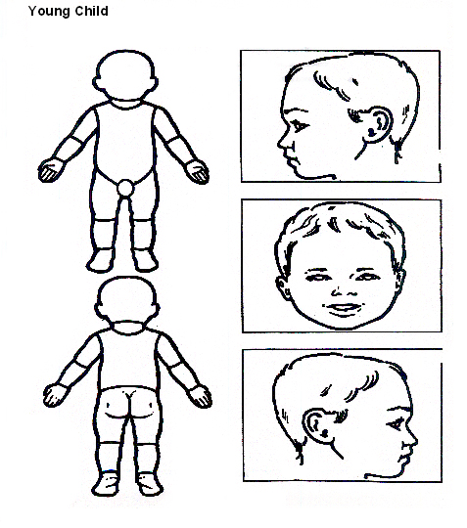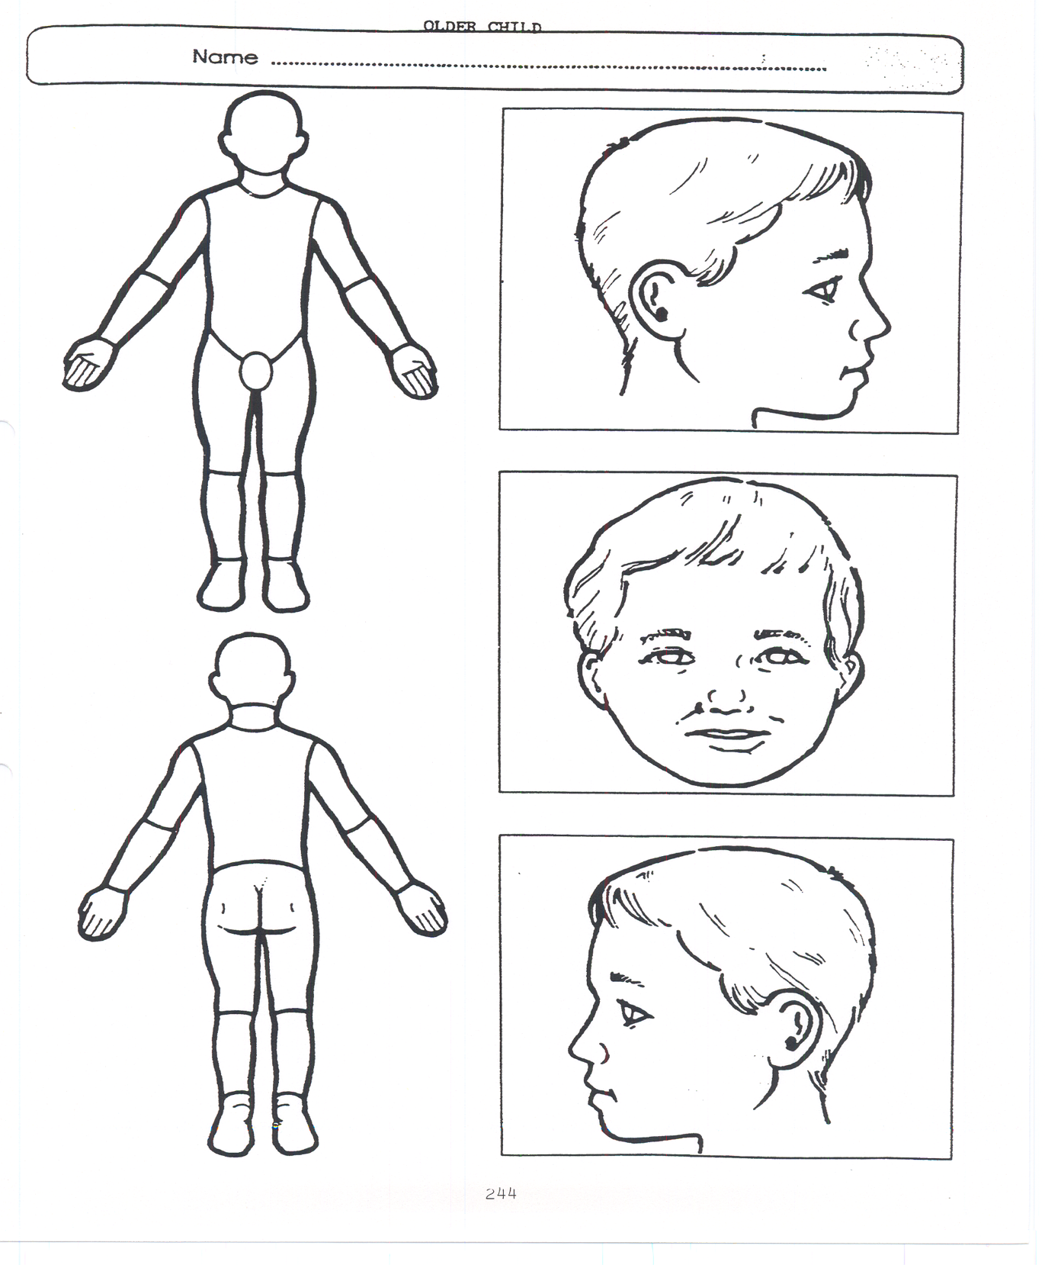

**Older Child**